### Thrust Bed Assembly Manual

1. **Introduction**
2. **Detailed List of Components**
3. **Components figures**
4. **Assembly Instructions**
5. **Safety Guidelines**
6. **Conclusion**

**Introduction**

This manual provides detailed instructions for assembling and maintaining the thrust bed stand. It is designed to guide users through the step-by-step process of correctly setting up the structure, ensuring stability and efficiency during operation. The document is intended for technicians, engineers, or individuals with basic technical knowledge who will be assembling or using the stand.

## Detailed List of Components

|  |  |  |  |  |
| --- | --- | --- | --- | --- |
| S.no | Component Name | Description | Quantity | Dimensions |
| 1. | 40x80 A Extrusion | Aluminum profile for base | 4 | 40mm x 80mmx1000mm |
| 2. | 40x80 B Extrusion | Aluminum profile  for base support | 2 | 40mmx80mmx85mm |
| 3. | 40x40 C Extrusion | Aluminum profile for angled support | 2 | 40mmx40mmx566mm |
| 4. | 40x40 D Extrusion | Aluminum profile for support | 2 | 40mmx40mmx85mm |
| 5. | 40x40 P Profile | Connectors for extrusion | 16 | 40mmx40mmx35mm |
| 6. | 40x40 T Sliding Nut | Sliding nut for fastening | 52 | 19.5mmx19.5mmx9.5mm |
| 7. | Corner Brackets | Securing extrusions for angled extrusion | 8 | 40mmx40mmx5mm |
| 8. | M8 Bolts | Standard bolts for assembly | 20 | M8 x 10mm |

**Components figures**

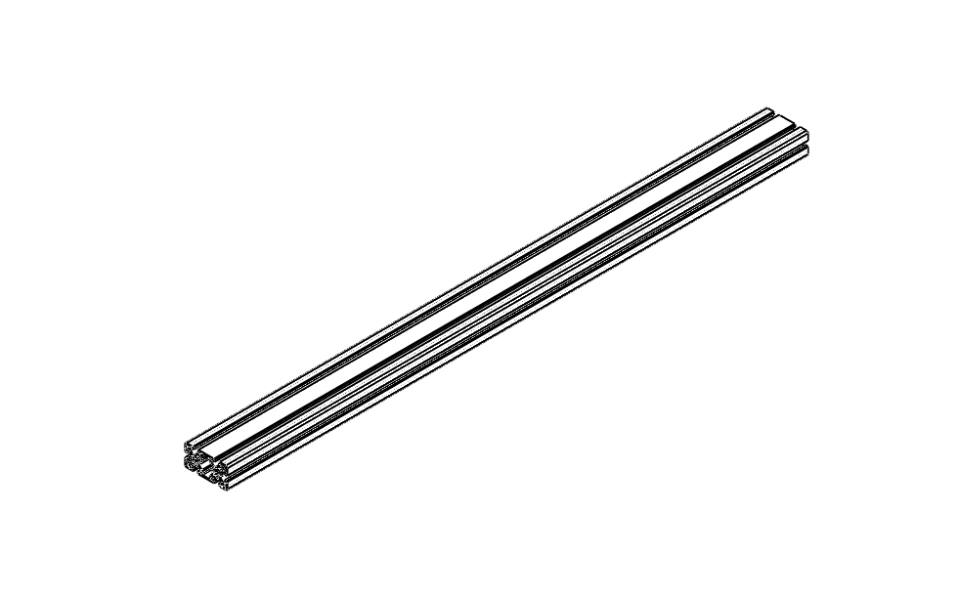 1.40X80 A IMAGE OUTLINE

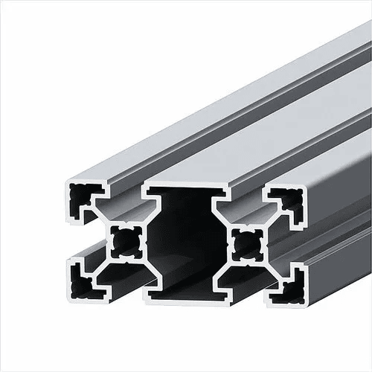

2.40x80 B IMAGE OUTLINE

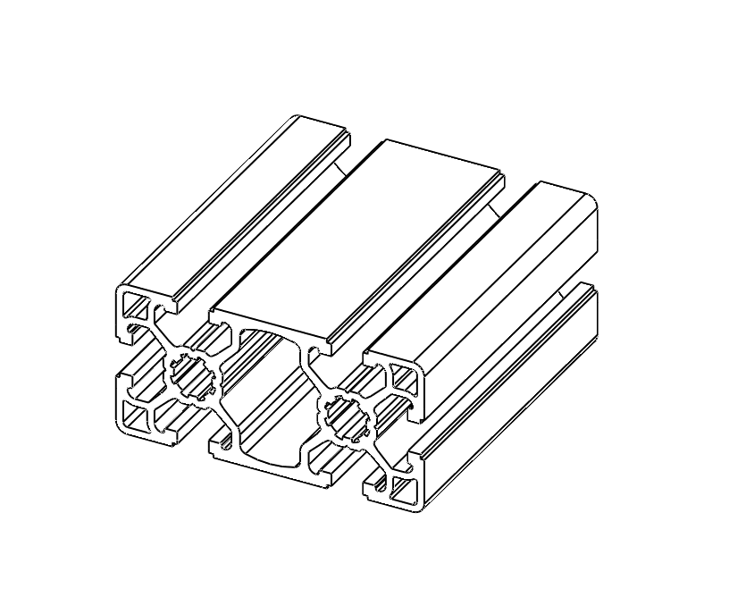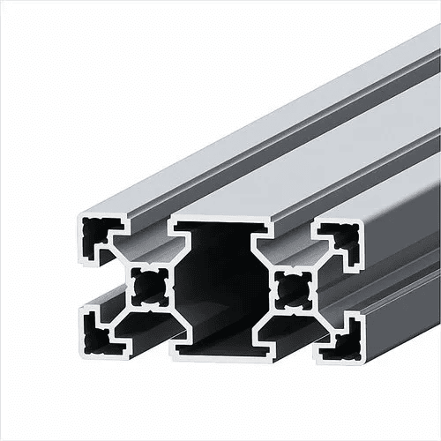

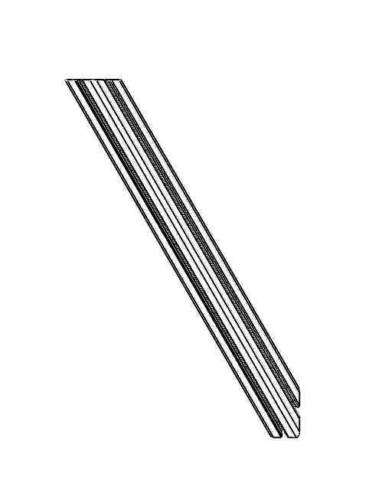3.40x40 C IMAGE OUTLINE

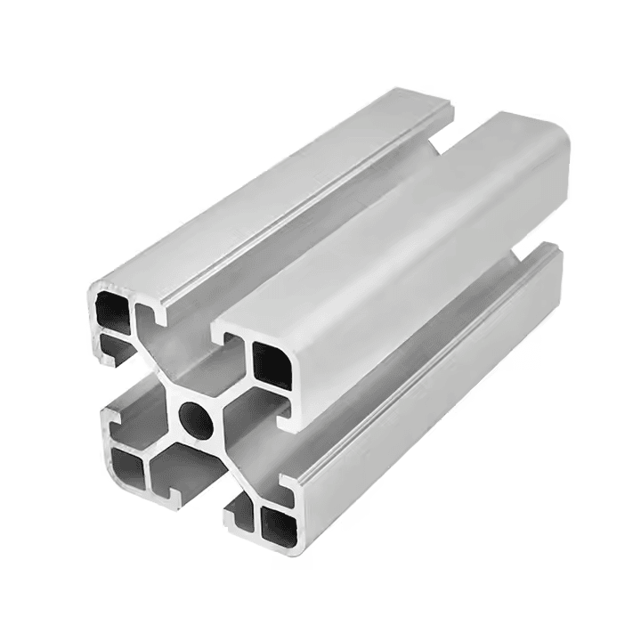

4.40x40 D IMAGE OUTLINE

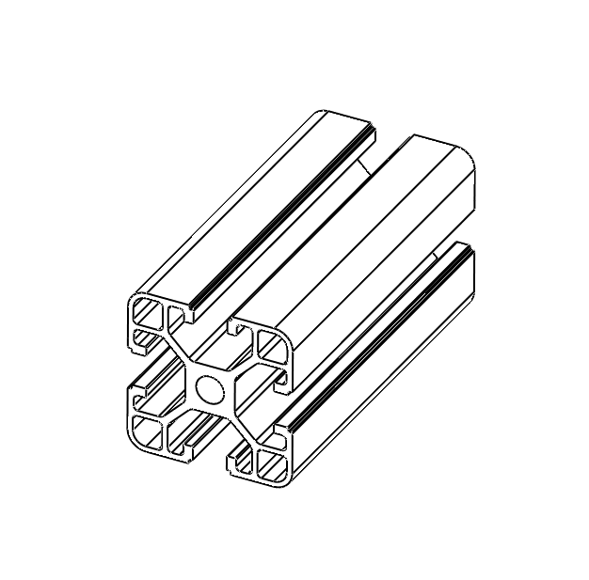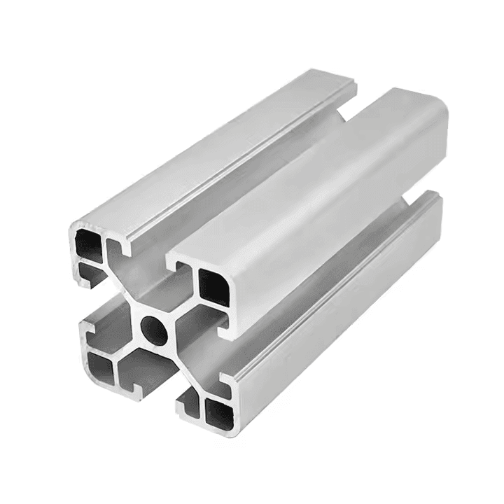

5.40X40 P IMAGE OUTLINE

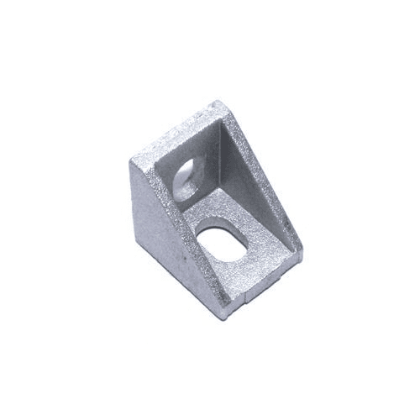

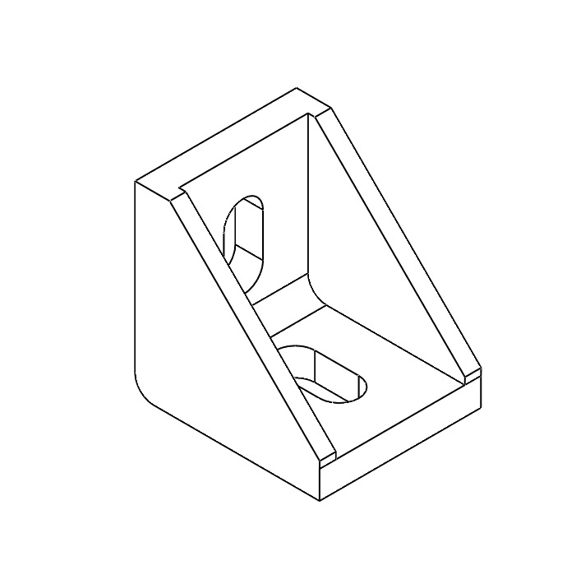

6.40x40 T IMAGE OUTLINE

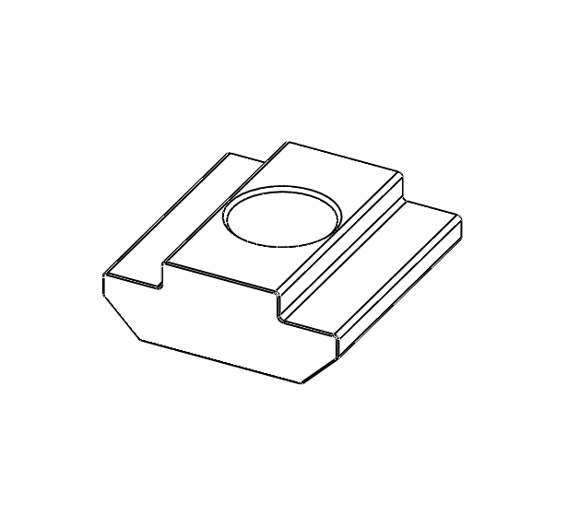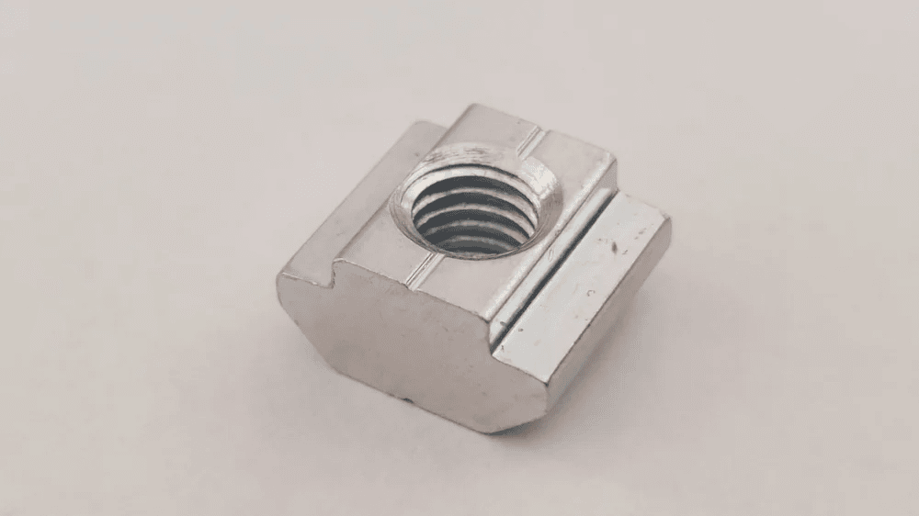

7.Corner brackets IMAGE OUTLINE

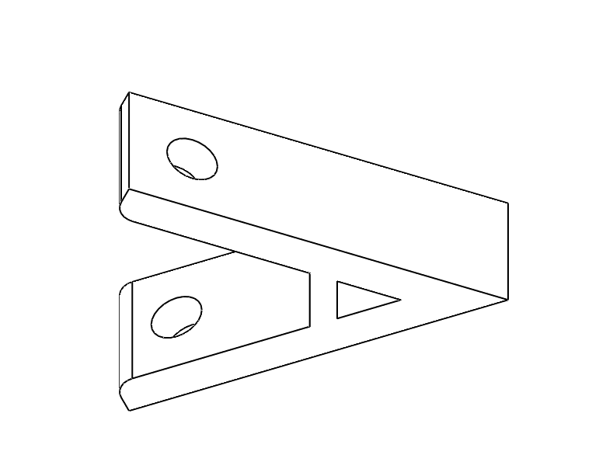

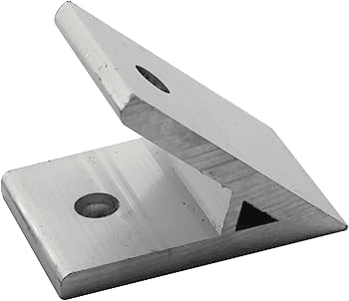

8.M8 Button socket bolt IMAGE OUTLINE

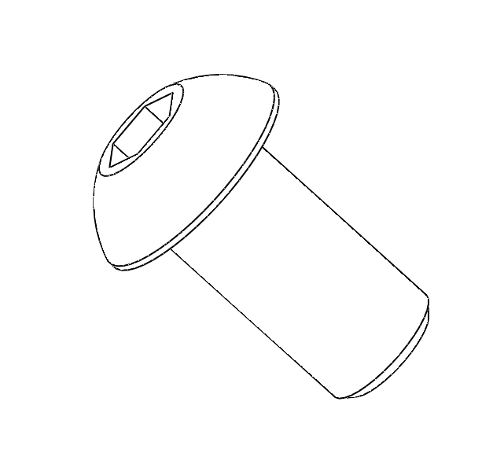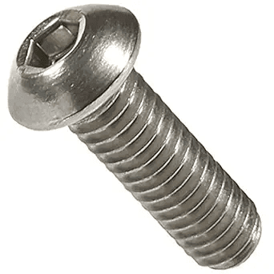

Assembly Instructions

Step 1 40x80 B Sub-assembly :

1. Prepare the Components:

* Gather the central aluminum extrusion 40x80 B (center piece).
* Identify the two triangular 40x40 P corner brackets.
* Locate the two sliding nuts 40x40 T (highlighted in green).
* Ensure you have the M8 two bolts (top-center).

2. Insert the Sliding Nuts:

* Slide one nut into the top slot of the central extrusion on each side as arrow shown in figure 1.
* Ensure they are positioned approximately where the corner brackets will be mounted as shown in figure 2.

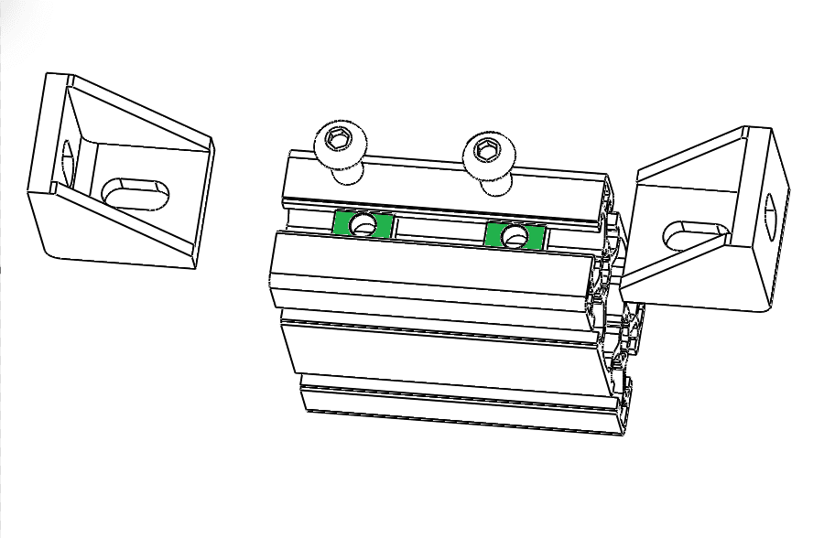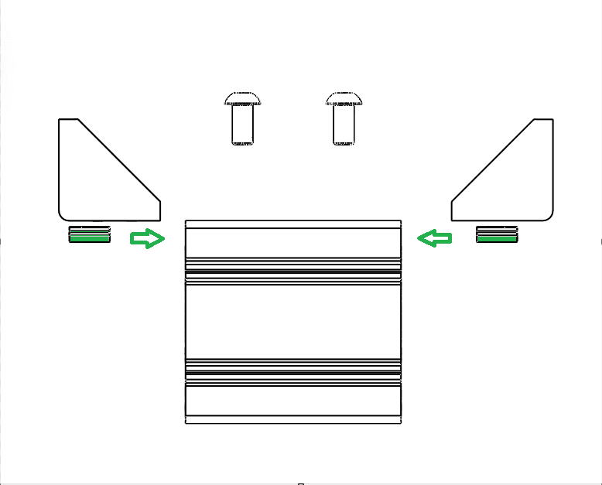

Fig : 1 Fig : 2

3. Attach the Corner Brackets:

* Place one triangular corner bracket 40x40 P against each side of the

central extrusion,aligning the holes with the sliding nuts inside the extrusion.

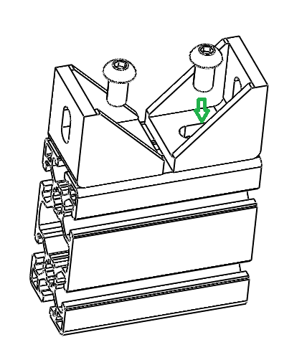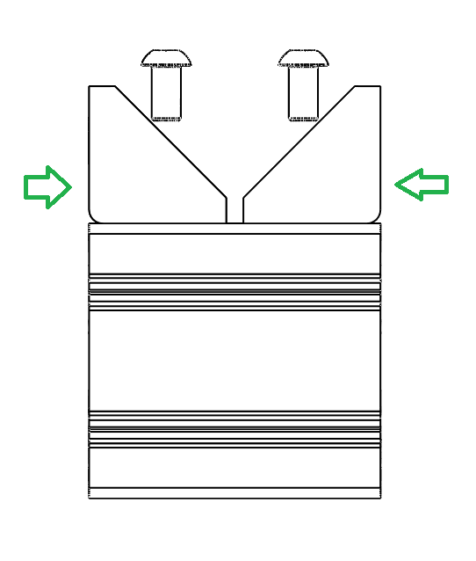

Fig : 4 Fig : 5

4. Insert and Tighten the Bolts:

* Insert a bolt through the hole of each corner bracket and thread it into the

corresponding sliding nut inside the extrusion as shown in Fig : 5 green arrow.

* Use a wrench or Allen key to tighten the bolts securely but

do not over tighten to avoid damage.

5. Final Check:

* Verify that the corner brackets are tightly secured to the central extrusion as show in as Fig : 6 and 6.1.
* Ensure the assembly is aligned properly, and there are no loose components.
* Follow the step 1 for another set of 40x80 B Sub-assembly.

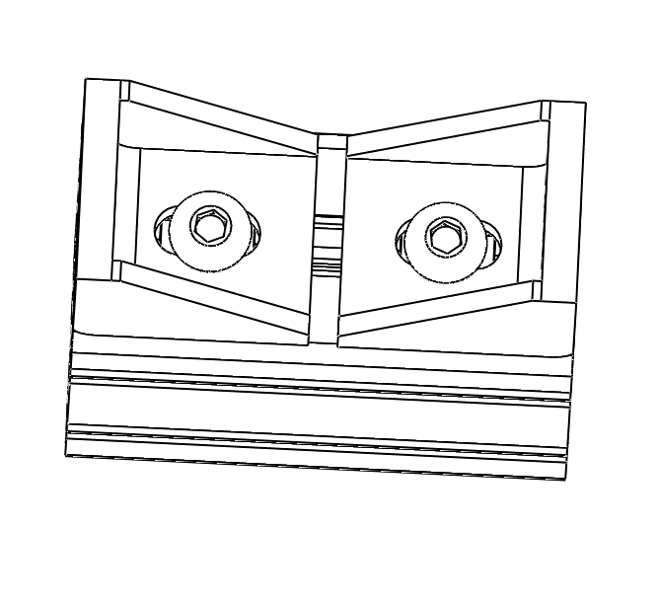 Fig : 6 Fig : 6.1

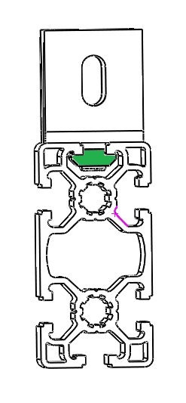

Step 2: Base structure assembly

1. Prepare the Components:

* Gather the two 40x80 A aluminum extrusion.
* Locate the two 40x80 B already assembled in the previous step.

2. Align the 40x80 B Sub assembly:

* Insert sliding nuts through the extrusion slots of the both 40x80A and both ends as shown in Fig:7.
* Position the 40x80 B sub assembly at each end of the 40x80 A aluminum extrusion as shown in Fig : 8 , 8.1 and 8.2.
* Ensure they are symmetrically aligned and flush with the central slot of the extrusion.

Figure : 7 Figure :7.1

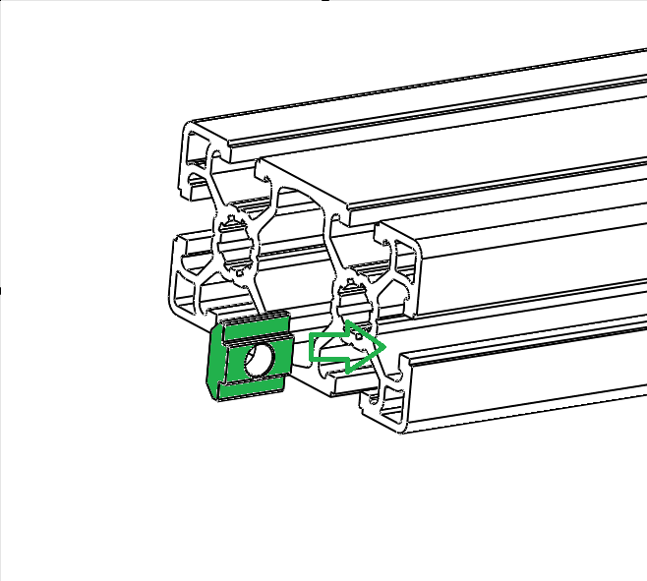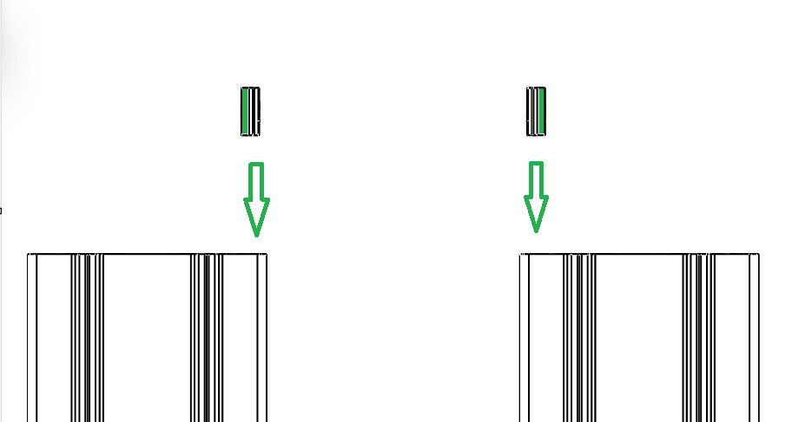

Figure : 8 Figure : 8.1 Figure: 8.2

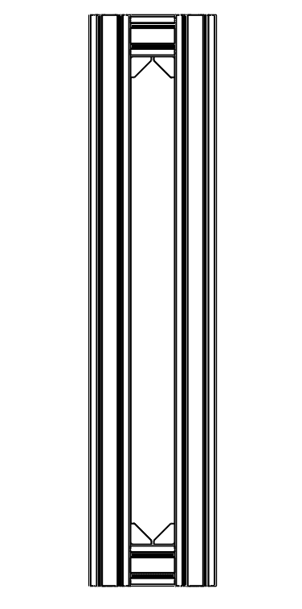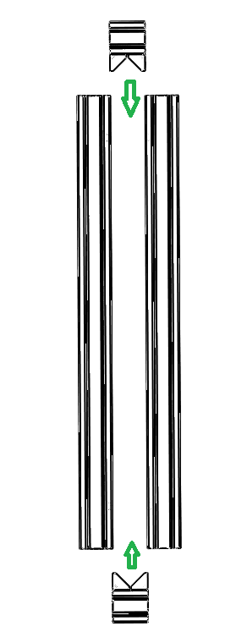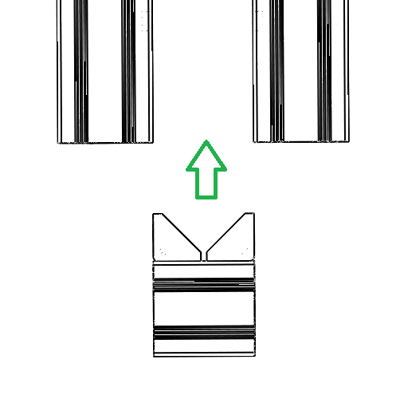

3. Secure the Brackets:

* Insert bolts through the 40x40 P brackets into the sliding nuts within the both 40x80 A extrusion slots as shown in fig: 9 and 9.1
* Tighten the bolts using a wrench or Allen key while ensuring the brackets remain aligned.

Fig 9 Fig 9.1

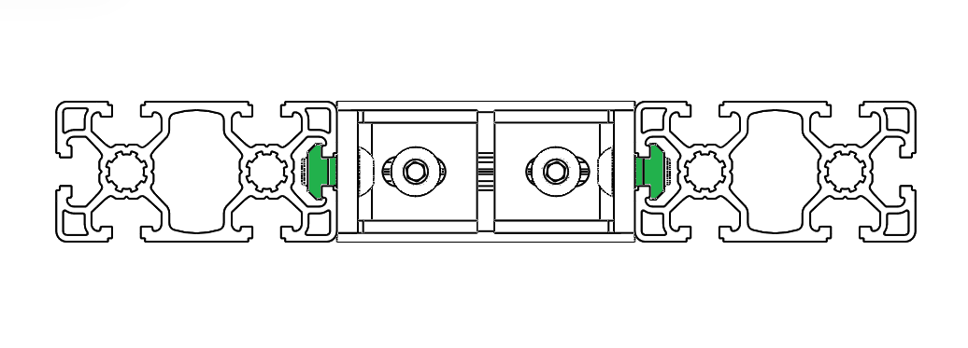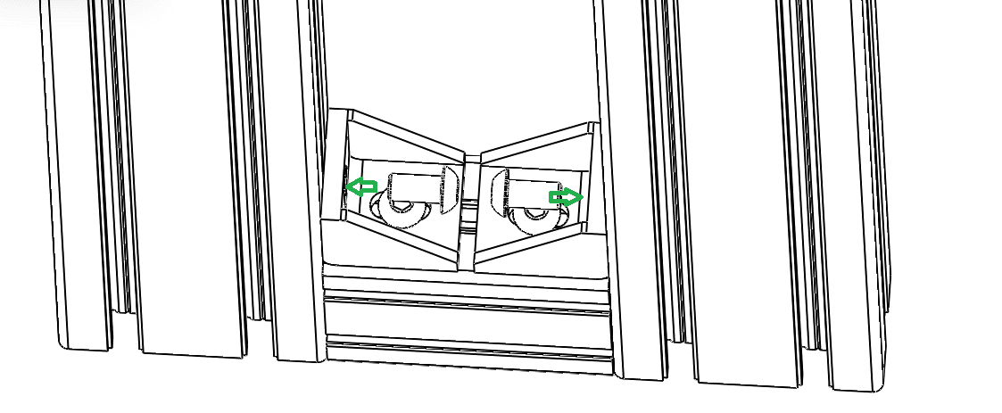

4. Check the Assembly:

* Verify that the brackets are firmly attached to the 40x80 A aluminum extrusion as shown in fig:10.
* Ensure there is no wobble or misalignment.

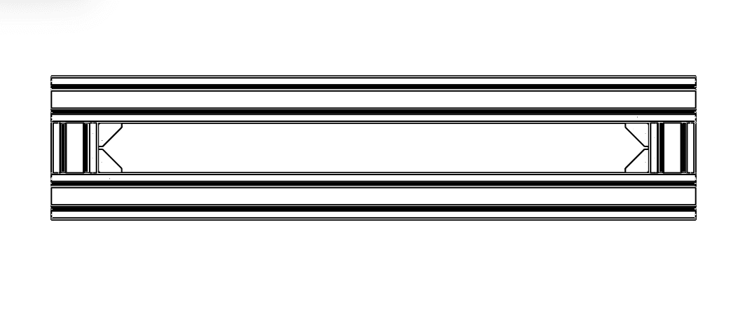 Fig : 10

Step 3 : Horizontal assembly structure

1. Prepare Components:

* Two vertical 40x80 A aluminum extrusions.
* Eight 40x40 P corner brackets.
* Sixteen M8 bolts.
* Sliding nuts.

2. Position the Vertical Supports:

* Place the two 40x80 A aluminum extrusions vertically center onto the base structure.
* Align them with the corner brackets on both sides of the base as shown in Fig : 11

Fig : 11 Fig : 11.1

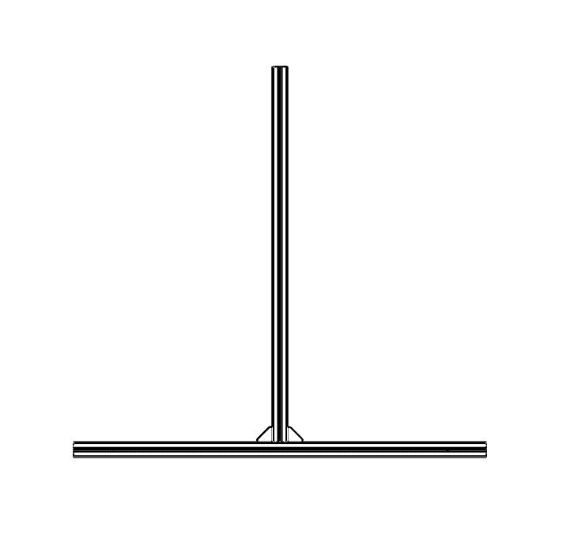

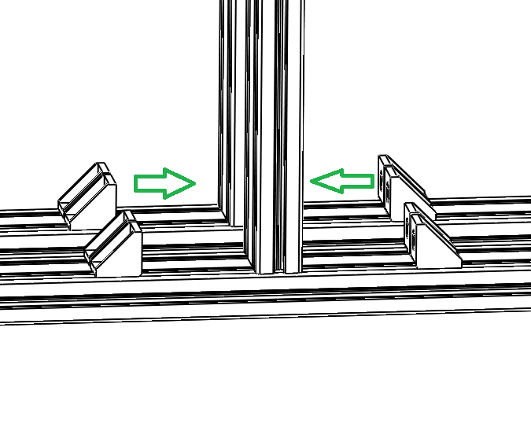

3. Attach Corner Brackets:

* Secure the bottom of each vertical extrusion using 40x40 P corner brackets at their base.
* Use M8 bolts, washers, and sliding nuts to fasten the corner brackets tightly to both the base structure and the vertical extrusions.

Fig : 12 Fig : 12.1

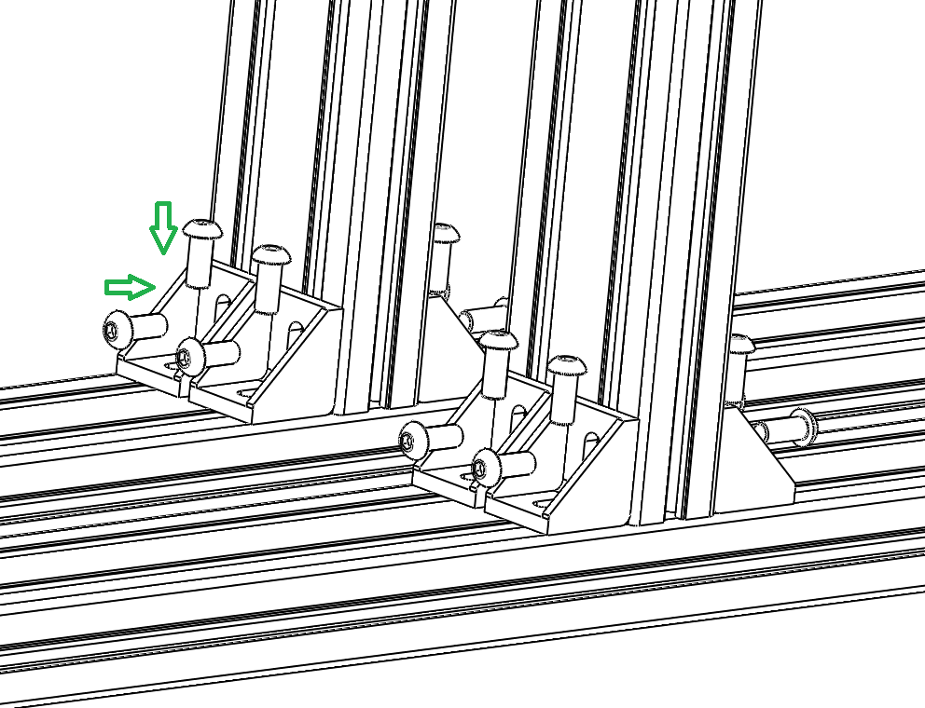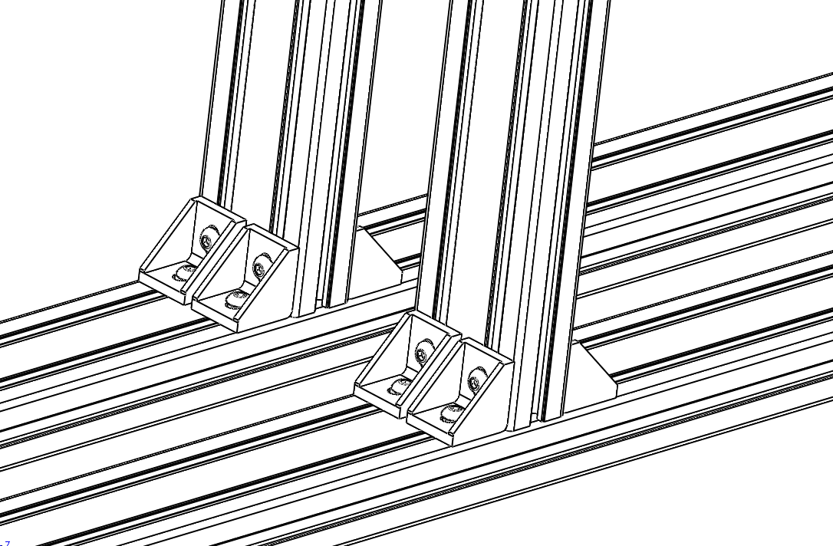

4. Verify Alignment:

* Ensure both vertical supports are parallel and perpendicular to the base.
* Adjust necessary to maintain proper alignment.

5. Tighten Fasteners:

* Once aligned, tighten all bolts securely to ensure a stable assembly.

Step 4: Assembly of 40x40 C Angled support

Components Needed:

* 40x40 C Diagonal Aluminum Profiles (4 pieces)
* Angled Corner Brackets (8 pieces)
* Sliding Nuts (8 pieces)
* Sixteen M8 bolts (M8 x 10mm)

Assembly Instructions:

Position the 40x40 C

* Take Four diagonal aluminum profiles and position them between one side of the vertical supports and the base frame as shown in Fig : 13.
* Ensure they are aligned at an angle, connecting the base structure to the vertical supports.

Fig : 13

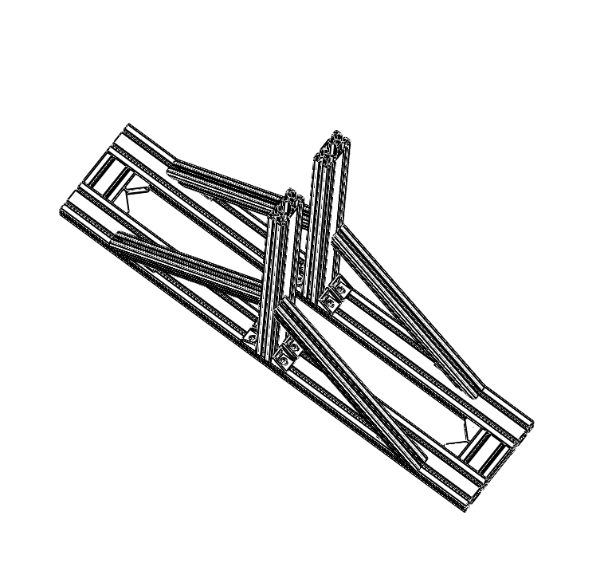

Fig : 14, 14.1 & 14.2

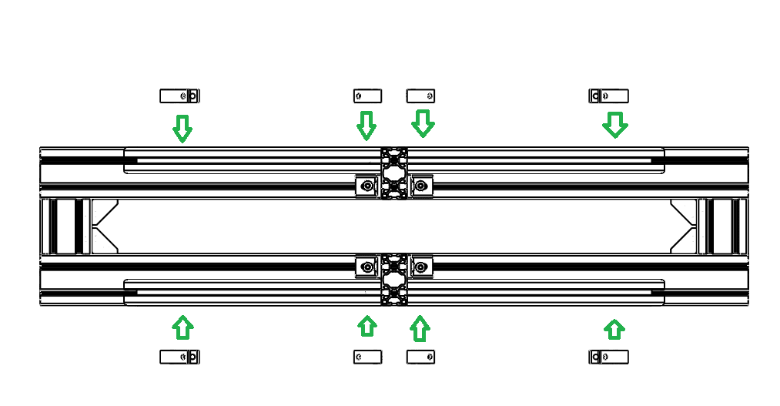

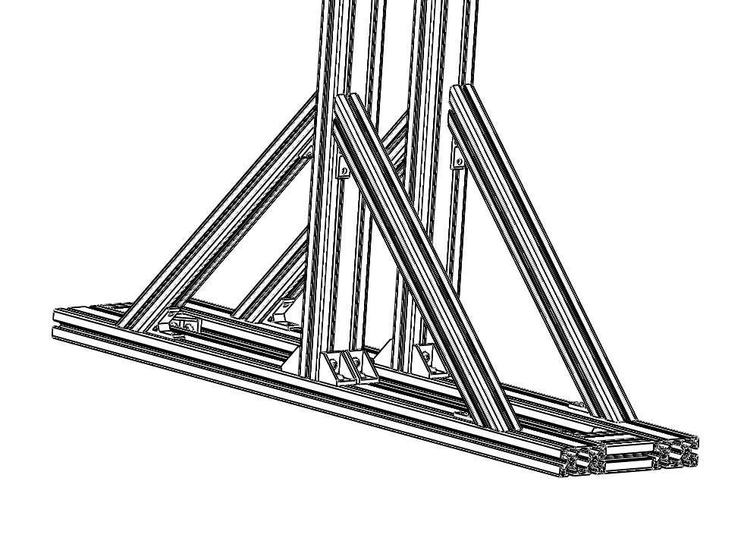

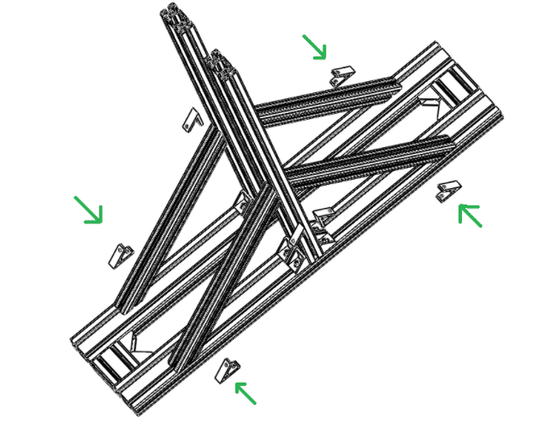

Attach with Angled Corner Brackets:

* Place angled corner brackets at each end of the diagonal brackets(4 in total for both sides)as shown in fig : 14 ,14.1 and 14.2.
* Align the angled corner brackets with the holes in the aluminum profiles as shown in Fig :15.

Fig : 15

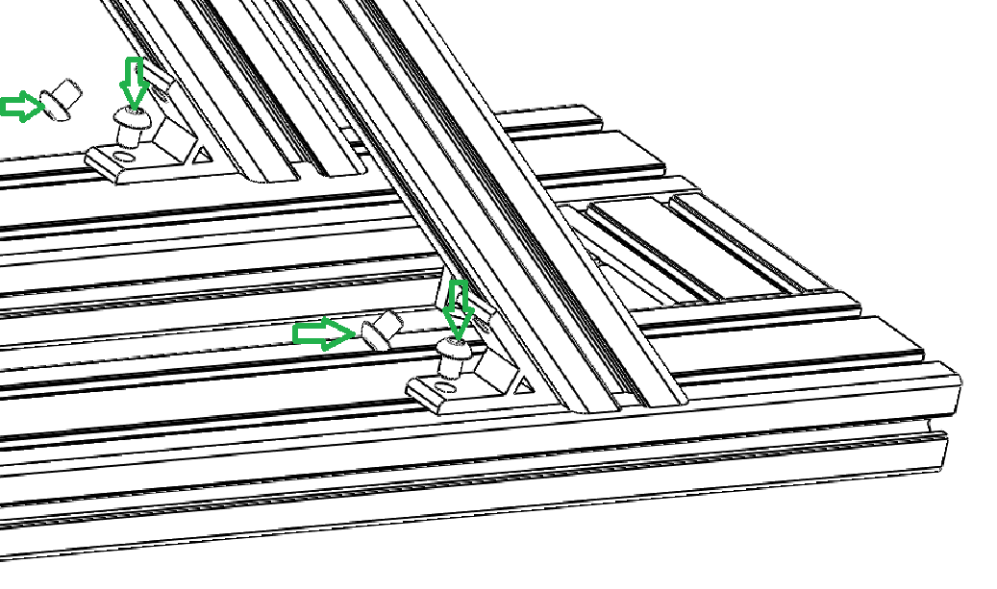

Install Sliding Nuts:

* Insert sliding nuts into the slots of the base structure assembly and vertical support extrusions where the bracket will attach.

Fasten with Bolts and Washers:

* Use M8 bolts to secure the angled corner brackets to the sliding nuts.
* Tighten the bolts evenly to ensure the brackets are firmly connected as shown in Fig:16

Fig : 16

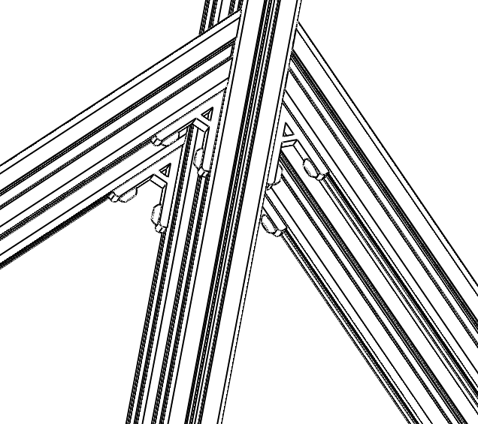

Repeat for the Opposite Side:

* Follow the same steps to install the two remaining diagonal brackets on the opposite side of the structure.

Check Alignment:

* Verify that all bracket are securely attached and the entire structure is aligned properly for stability.

Step 5 : Assembly of 40x40 D aluminum extrusion

Prepare Components:

* Obtain two 40x40 D aluminum profiles to act as connectors between the vertical aluminum profiles.
* Gather the necessary bolts and brackets to secure these profiles in place.

Position and Attach Connectors:

* Position the 40x40D aluminum profiles as shown in the fig 17, aligning them centrally with the structure.
* Secure the top of the 40x40 D to the vertical extrusion using 40x40 P L-brackets and sliding nuts.
* Ensure the profiles are parallel and aligned with the previously installed structure.

Fig : 17 Fig 17.1

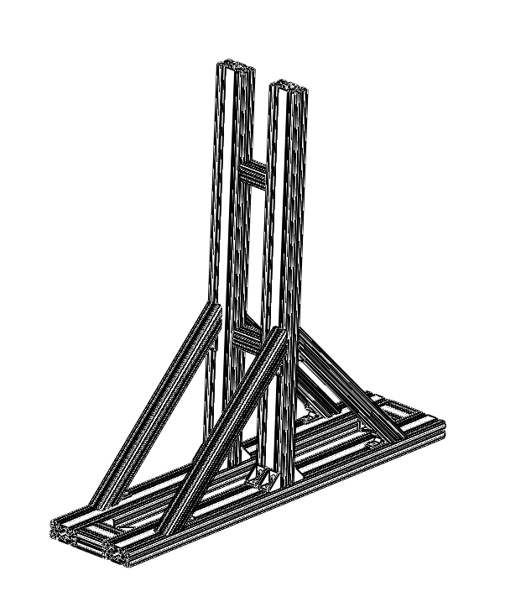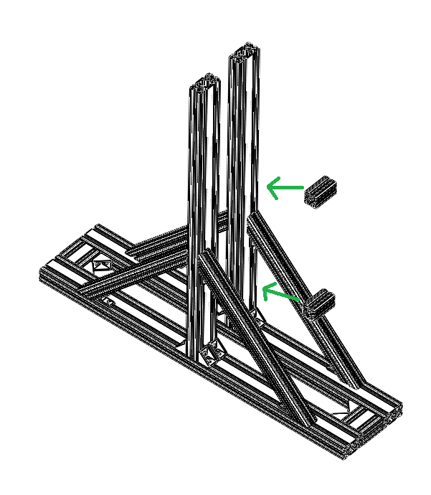

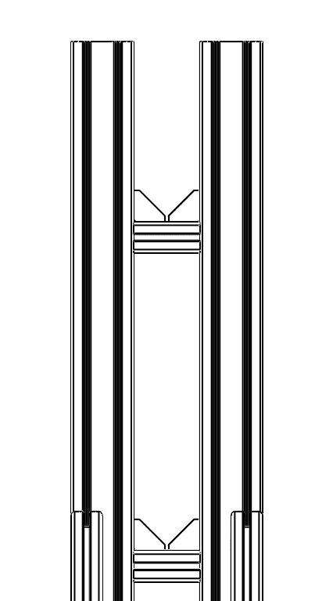

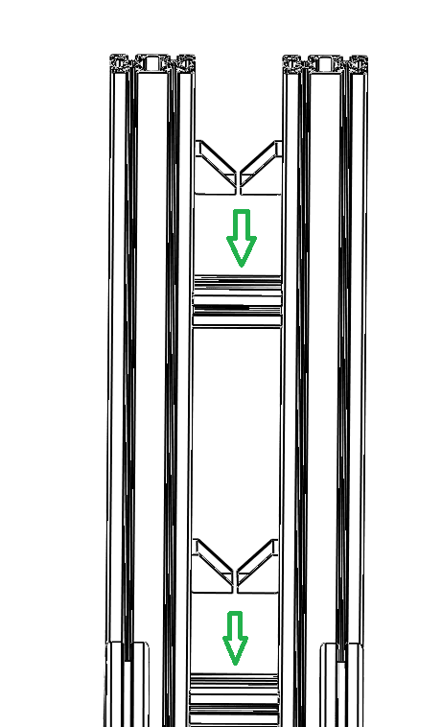

Fig : 18 Fig 18.1

Install Sliding Nuts:

* Insert sliding nuts into the slots of the vertical structure assembly and 40 x40 D extrusions where the 40 x40 P bracket will attach.
* Tighten all screws securely to ensure stability as shown in Fig 19 and 19.1.

Check for Stability

* Verify that all parts are securely attached and that the entire assembly remains sturdy.
* Make any necessary adjustments to ensure proper alignment and balance.

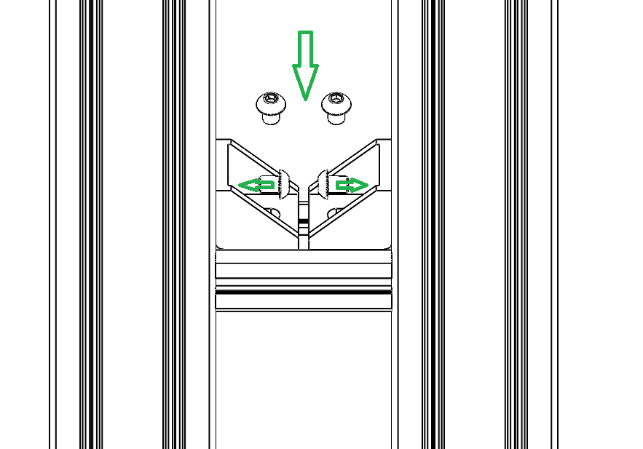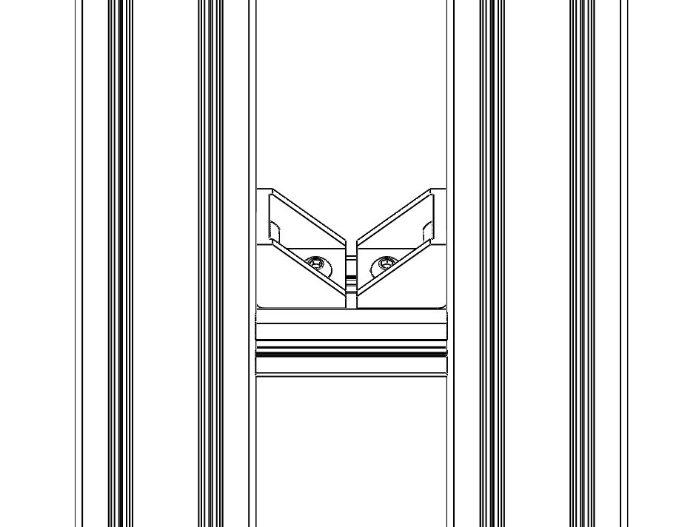 Fig 19 Fig : 19.1

Safety Guidelines :

**Maximum Propulsion Power:**

* Ensure the thrust bed stand is only used for propulsion power up to 50kg.
* Do not exceed this limit to avoid potential structural damage or instability.

**Securing to the Ground:**

* Attach the base structure to the ground using heavy-duty anchor bolts or U-clamps.
* Ensure that the ground surface is even and strong enough to bear the vibrations and forces exerted during operation.

**Adding Weights for Stability:**

* Place additional dead weights (e.g., sandbags, concrete blocks) on top of the base frame.
* Distribute the weights evenly to prevent tilting or shifting of the structure during propulsion tests.

**Check for Movement:**

* Before running any tests, verify that the stand is firmly secured and does not move when force is applied.
* Perform a trial run with reduced propulsion power to confirm the stability.

**Inspect Fasteners and Joints:**

* Ensure all fasteners, brackets, and screws are securely tightened.
* Regularly inspect these parts for any signs of wear or looseness after each test.

**Propulsion Direction Alignment:**

* Verify that the thrust direction aligns perfectly with the stand’s axis to minimize lateral forces that could cause instability.

**Safety Precautions:**

* Keep personnel clear of the testing area, especially towards propulsion.
* Install safety barriers or enclosures around the stand to protect against potential debris or accidents.

Fig: 20

